 ^{Sive} Brakel, Germany 2022
________________________________________
Cork College of FET, Tramore Road Campus,
Cork, Ireland


Biodiversity & Travel

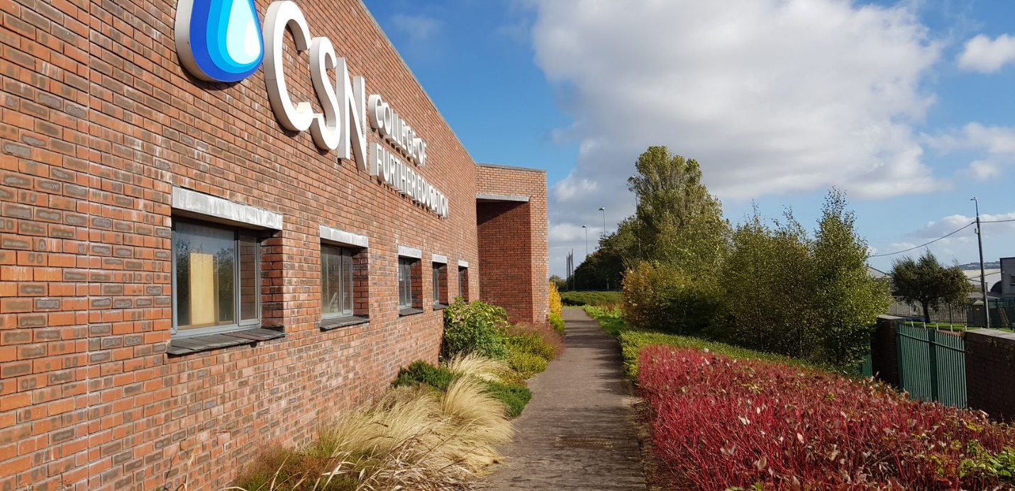

Biodiversity at Tramore road campus:
Biodiversity is very important to us at Tramore road campus. We are fortunate that we have such a large campus with so much green space. The space gives us a great opportunity to promote biodiversity which is particularly important within our sub-urban setting.
The campus consists of 6 hectares, two thirds of which is plant cover such as grass, woodland etc.
Students studying Horticulture and Greenkeeping have identified 16 different habitat types on the site as defined by the “Fossitt” Guide to Habitats in Ireland, 2000. These include:
- Amenity Grassland (GA2)
- Dry Meadows and grassy verges (GS2)
- Horticultural land (BC2)
- Flower Beds and Borders (BC4)
- Buildings and artificial surfaces (BL1)
- Re-colonising bare ground (ED3)
- Exposed Calcareous Rock (ER2)
- Mixed Broad-leaved Woodland (WD1)
- Mixed Broad-leaved/Conifer Woodland (WD2)
- Scattered Trees and Parkland (WD5)
- Scrub (WS1)
- Immature Woodland (WS2)
- Ornamental/Non-native shrub (WS3)
- Hedgerows (WL1)
- Treelines (WL2)
- Other artificial lakes and ponds (FL8)
Each of these habitats supports a specific range of plants. Some photos are included below.
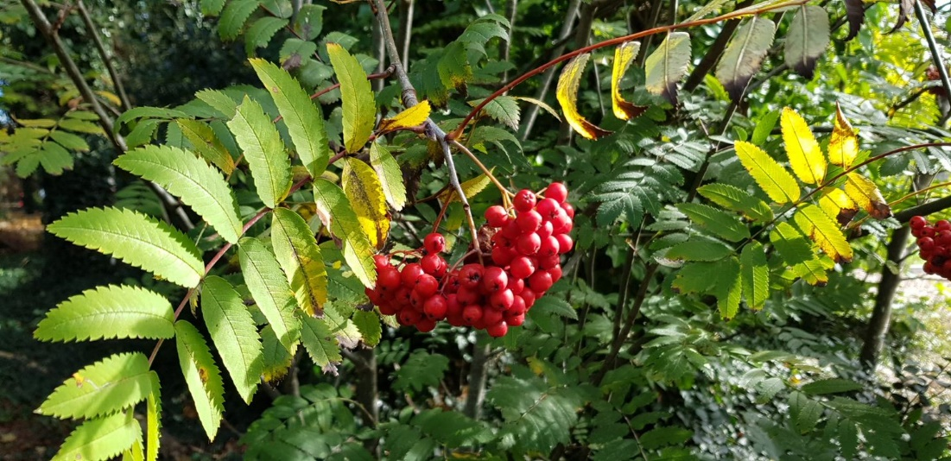

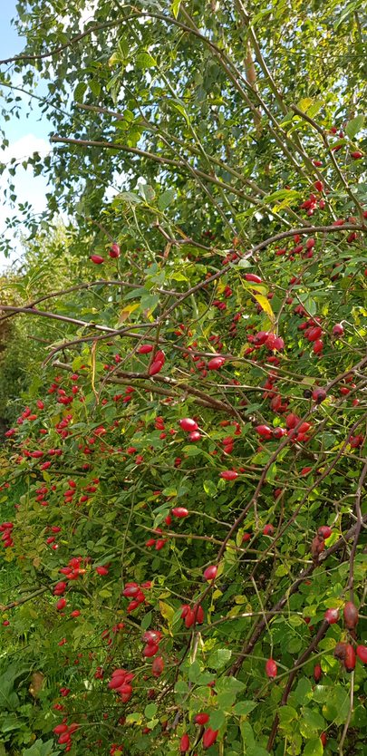
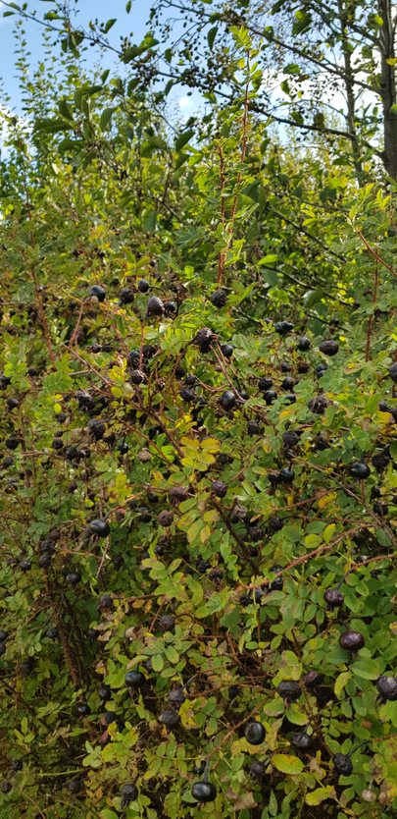
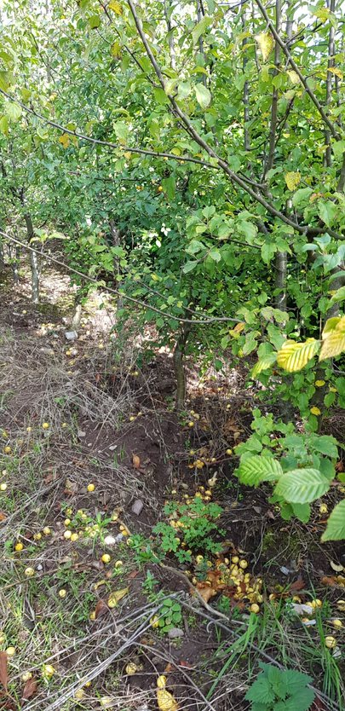
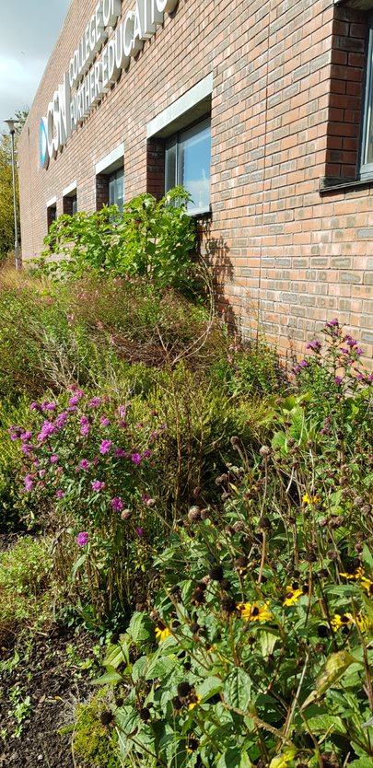
The plants and habitats outlined above provide food and shelter for animal species. The key element here is that the greater range of habitats that we can have on site then the greater range of plants we will be able to support. The wider range of plants we can have then the wider range and greater number of animals species the site will support. The range of animal species supported at CSN includes invertebrates such at woodlouse, earthworms, slugs, snails, beetles, bees, butterfly, hover flies etc, birds such as robin, blackbird, wood pigeon, blue tit, starling, gold finch, jay, and mammals such as wood mouse, shrew, bat, fox, hedgehog.
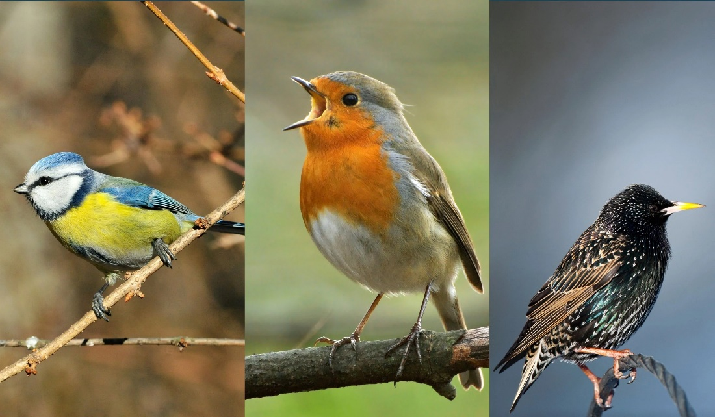
Lawn management:
Lawns are strategically managed as short-flowering or long flowering meadows so there is always a rich supply of food available for pollinators. Lawns are not treated with selective herbicides to promote a wide range of species. We reduce pesticide use on-site by managing weeds and other pest using cultural or physical methods wherever possible. Reducing fertiliser inputs by mulching grass clippings back into the lawns and pitches so that the nutrients are returned to the soil.
A focus on native planting:
For many years now we have focused on increasing the number of native plants on-site. This is important as native plants are generally going to support more animal species that introduced plants. Our horticulture students will be designing and managing landscapes into the future, so we have a responsibility to ensure that they understand the value of native planting and how to create native planting schemes.
We propagate and grow native trees. Shrubs and herbaceous species on-site in our nursery (pictured below) and transplant them into specific areas of the site to increase the habitats. A good example of a native woodland that we have created in the past 4 years is outlined in the photos below. This woodland contains more than 30 species of native trees and shrubs can be seen supporting a wide range of insects and birds. The area also improves the air quality, reduces noise, and creates an aesthetically pleasing environment.
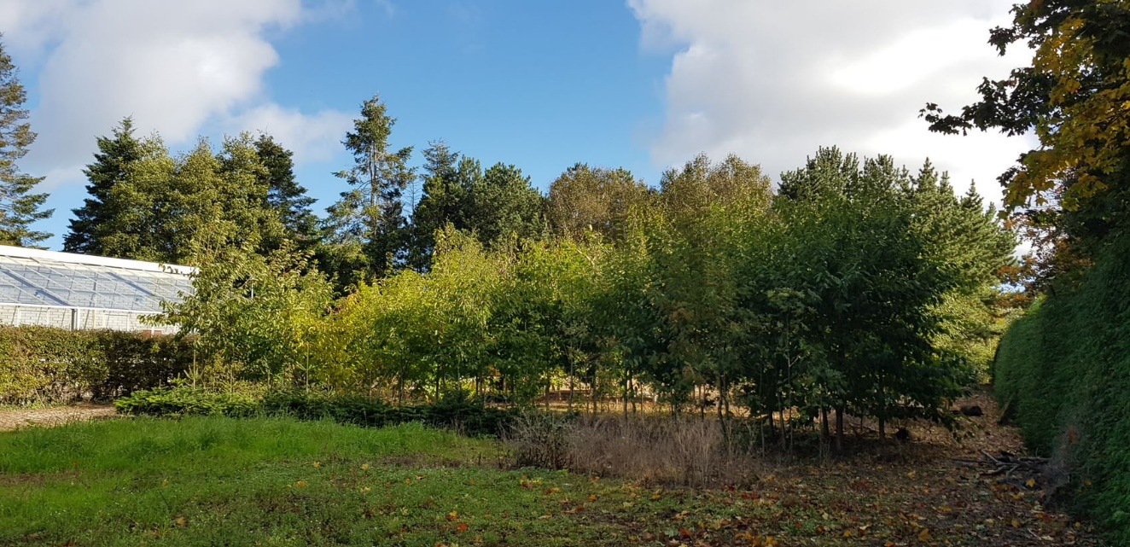
Woodland walk:
Earlier this year we developed a woodland walk around the perimeter of the campus, it is a little over 1km long. From a biodiversity perspective this path is now bringing staff and students from all courses in the college out around the grounds daily. Whereas in the past perhaps only the greenkeeping and horticulture students would have explored these areas. It’s great that all students are now readily exposed to nature, and we hope that this will lead to a greater appreciation of the natural environment by all our students and staff. When our students graduate and move on, we believe they will be better equipped to support biodiversity projects in their own communities.

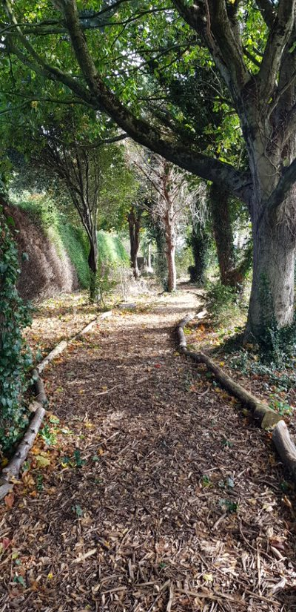
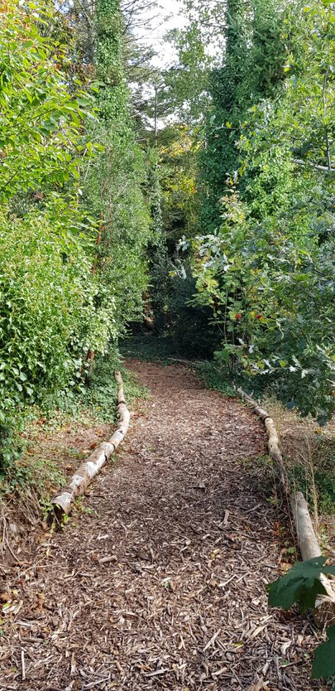
Keeping pruned or dead plant material on-site:
As part of the management of the grounds we endeavour to keep all plant material on-site. This not only reduces the volume of waste that would otherwise have to be removed but also improves the soil and promotes biodiversity. Examples of this are:
- Composting green waste – promotes invertebrate activity and improves the organic component of the soil on site over time.
- Chipping branches and using the mulch for paths.
- Using limbs of felled trees to create path edges which support biodiversity as they decay.
- Gathering wood and stumps into log-piles which are placed in the woodland areas. These log piles support fungi, lichens, mosses, and insects. Which in turn become food for birds. And these log piles are also ideal homes for over-wintering insects and small mammals such as field mouse and hedgehog.

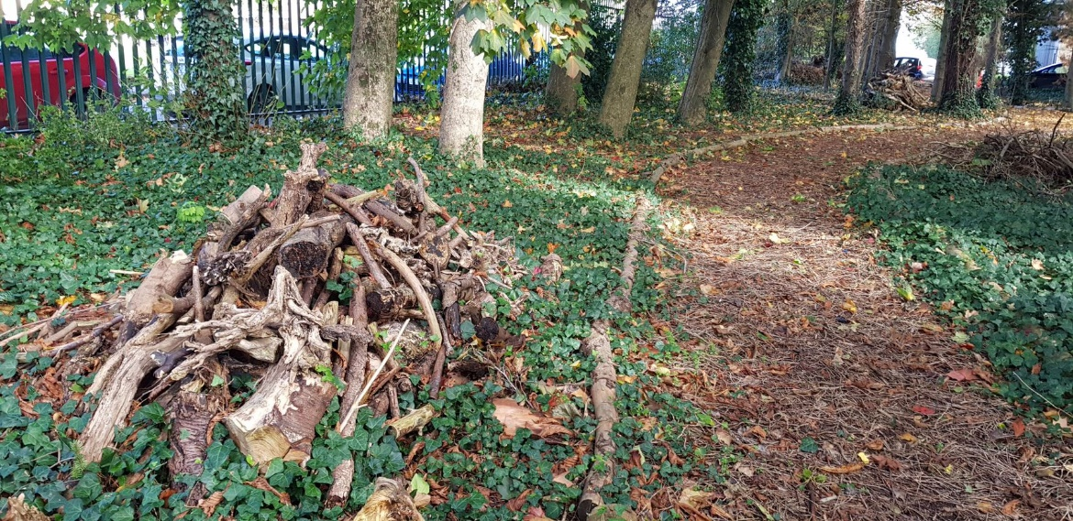
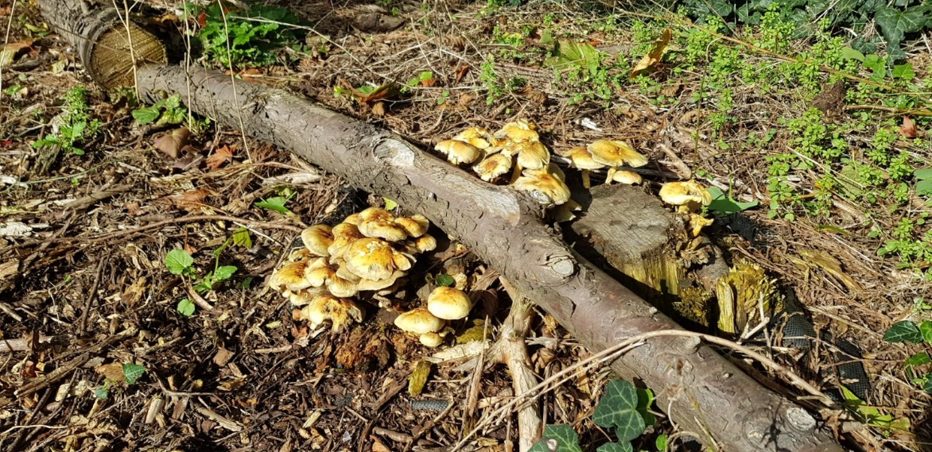

Recording Biodiversity:
Horticulture and greenkeeping students record plant and animal species found at CSN using the National Biodiversity Data Centre.

Improvements for the future:
- The green campus committee have identified that we should try to do a better job of highlighting the range of habitats and species that are supported on our campus. We will do this by using posters such as the one below.
- It has also been proposed that Horticulture teachers and students would organise various nature walks around the campus were they would show other students the rich range of species that the campus supports and explain to them how they can help with biodiversity on our campus or in their own communities.
- Create a larger pond to encourage wildlife. Ponds a rea great way to promote biodiversity and at present we only have a very small pond. So, we would like to develop one or two larger ponds on campus. Our next step is to select a suitable location for a new pond.
- We plan to take part in the Brid Watch Ireland Irish Garden Bird Survey this coming winter. The survey will involve staff and students recording bird species on campus each week from late November to late February. We are very excited to see the results of this survey. While we know that we have several bird species nesting and feeding on-site at present we hope that this survey will give us a better idea of the range and density od bird species. And this is something that we can then do each winter to build up or data and awareness over-time.
- Having created the walk around the pitches, we now have a south-facing steep bank that runs along the Northern boundary of our playing pitches. This area is approximately 190m long and 8m wide. We have a plan in place to create some valuable habitats on this site including native wildflower meadow and native woodland. We already have the trees and shrubs grown in out nursery and these will be transplanted this coming winter. The wildflower meadows will be established using native wildflower seed that have Irish provenance.

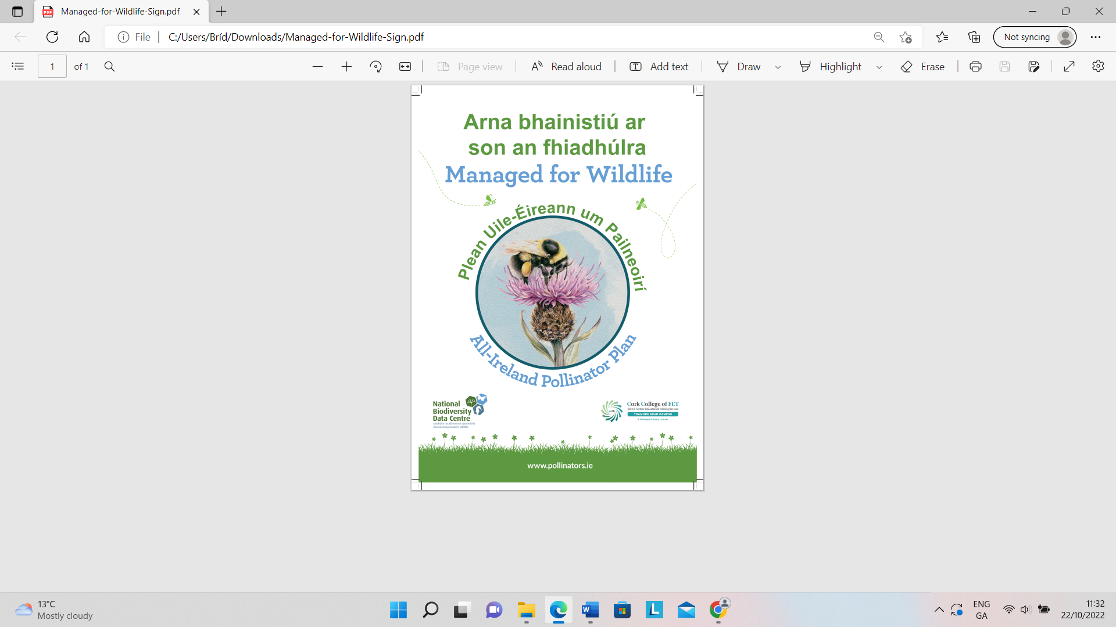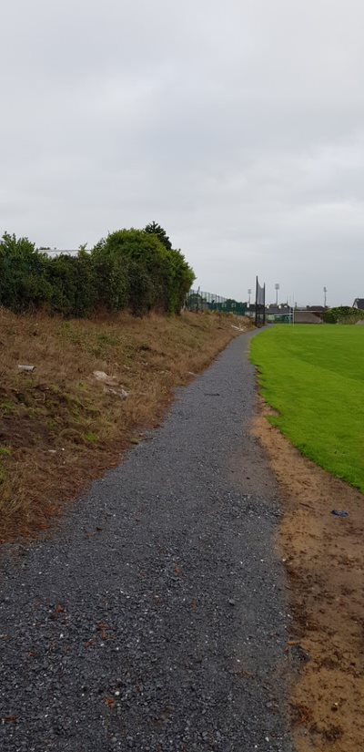
Transport/ Travel at Tramore road campus:
Staff and students use a variety of means to travel to and from college. These include private car, public bus, train & bus, E scooters, cycle and walk.
Our campus is located 3km (40min) from Cork city centre. Public buses to a wide range of destinations are available from Cork city centre. We are 4km (52min walk) from Kent Train station in Cork City. Many of our students use public transport in the mornings to get to Cork city and then they either walk to campus from there or they take a public bus. The college is served by two public buses the 203 which stops outside the college gates and runs every 20 min at peak times. And the 214 which stops 1km from the college and also runs every 20 min at peak times.

A map of the bus and train services is displayed at the college for students and visitors, as shown below.

Car parking:
The carparks are usually kept full throughout the day. Some of our staff and students do not live within reach of public transport and may be too far away to walk or cycle so it is expected that there will always be a percentage of people who travel to campus using private cars.

Match/Field trips using buses/trains:
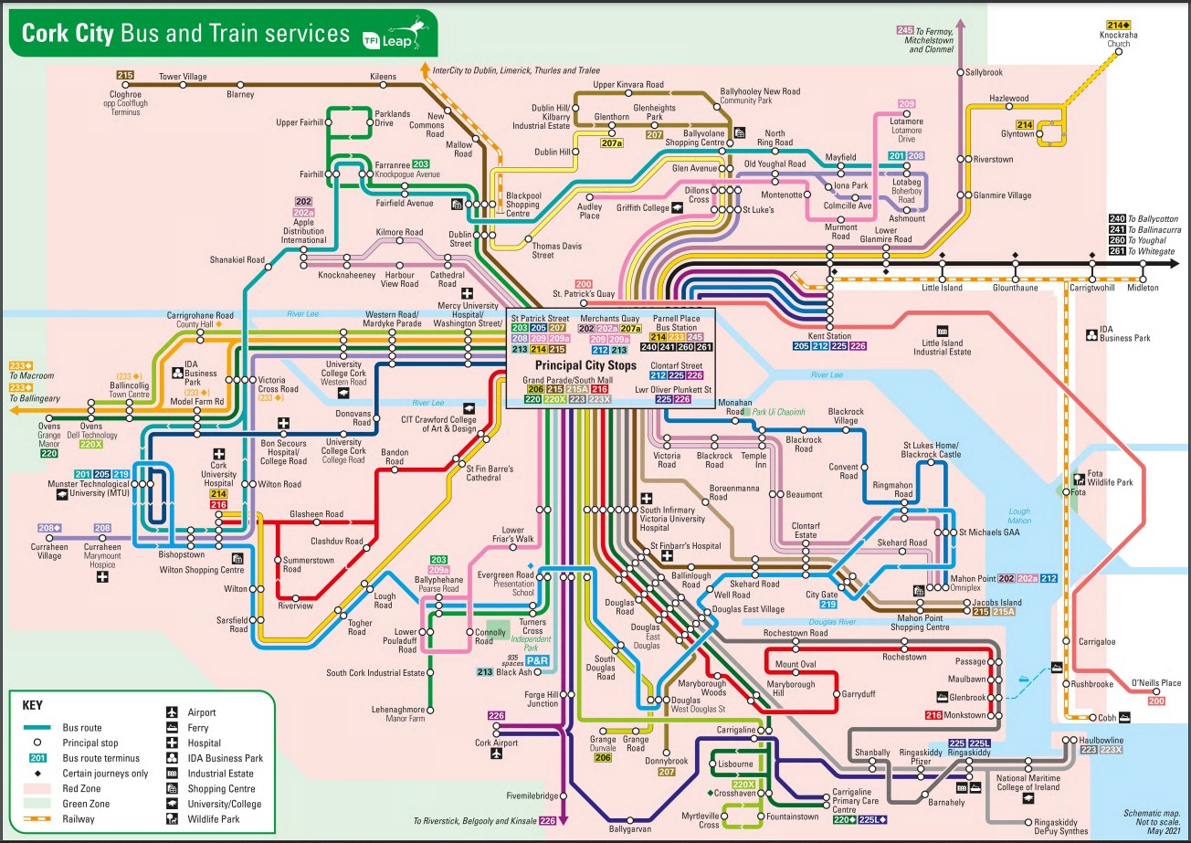
When staff and students travel for field trips or sports activities, they use buses or train primarily and for shorter trips we would car-pool to reduce the number of vehicles on the road.

Promote students to live near campus:
The college keeps an up-dates list of local accommodation so that when new students apply and need to find accommodation, they are encouraged to find local accommodation so that they can walk or cycle to the campus.

Conducting on-line interviews to reduce travel
All students who apply for a place at our college are interviewed and where a students may have to travel a large distance these interviews are carried out via on-line video conference to reduce mileage that a student would have to cover.

Survey Students and staff:
To have better data around the transport habits of our students and staff we need to conduct a survey. This is something that has been discussed by the green campus committee. We hope to carry out this survey in this academic year. We will be looking to see exactly how many people travel by car versus, public transport versus walk/cycle. We hope to be able to sue this data to invest in strategies to better serve everyone’s travels needs while also reducing our carbon emissions.

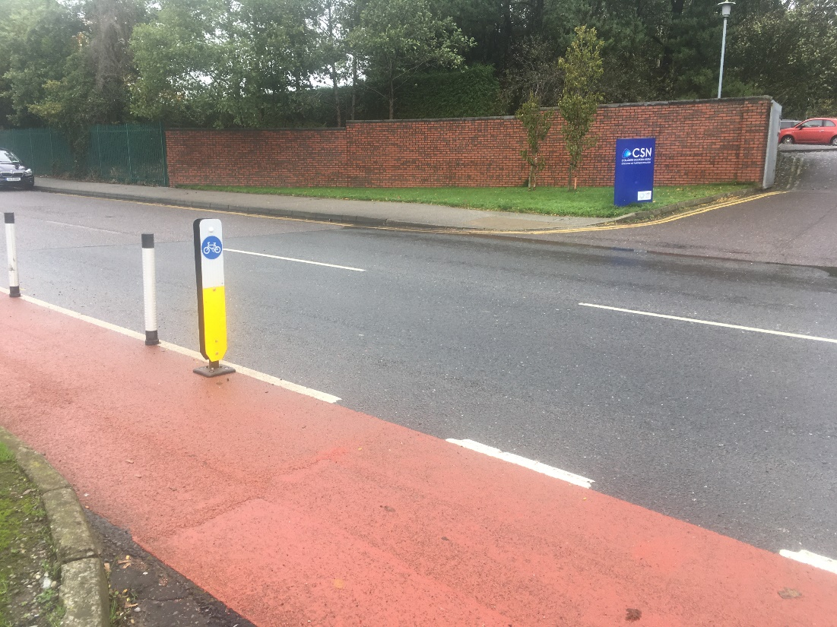
Bike lane shown across the main entrance to campus. This bike lane runs along Tramore Road.
TFI bikes:
Around the Cork city centre there are 36 bikes stations that support a self-service bike rental scheme known as “TFI bikes”. An annual pass can be purchased for 10 euro and rental is free provided that the bikes are returned to another stand within 30 minutes. There currently aren’t any TFI bike stands close to our campus, but we have made inquiries about having one installed and we believe this would be a positive move for the future.
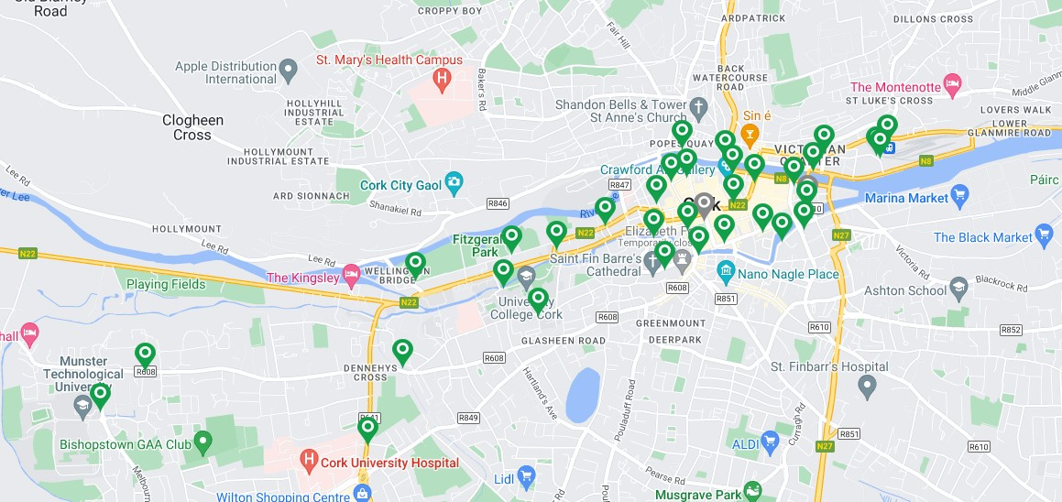
E-charging stations:
With the number of electric vehicles increasing every year we believe that installing e-charging stations on our campus would be a positive move for the future.

Green Week 2023:
A suggestion that has come from our green campus committee is that for green week in 2023 we might promote alternative modes of transport. In order to reduce carbon footprint, we could ask staff and students to choose walking, cycling and public transport and car-pooling over private cars in order to create some awareness and to identify new opportunities or outfalls that may be present.
Carpooling within classes and courses are common but non-existent between curricula. Also, most car users travel alone, so facilitating car-pooling to students and staff by compiling journey details could be a way for people travelling from the same directions and areas to travel together.

Challenges:
Traffic congestion in the city is an issue and makes for long commutes, however this could be used as an encouragement for people to select other modes of transport.
Public buses at peak times are sometimes full and unable to accommodate the high numbers of commuters. The National Transport Authority is investing €600 million, aimed at increasing the number of people using public transport, cycling, and walking in the city.
Some of the challenges are beyond our control but we could approach the public services in order to bring solutions to our problems in the transport and travel area.

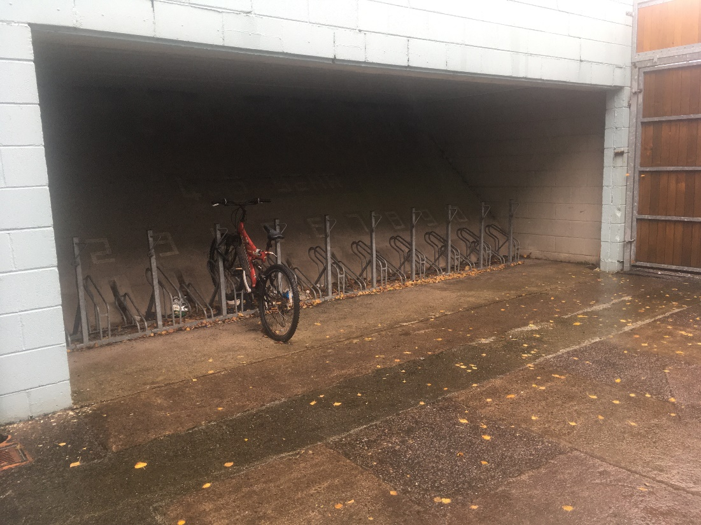
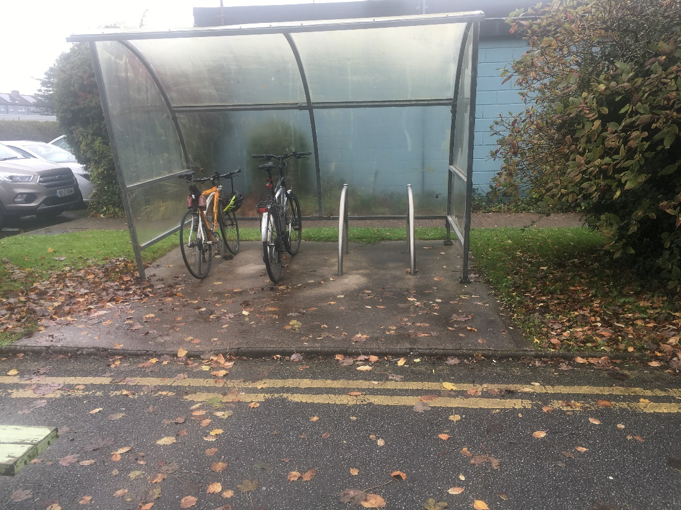
Bike shelters at Tramore Road Campus

