 Sive **Brakel, Germany 2022**

**________________________________________**

**Cork College of FET, Kinsale Campus,**

**Co. Cork, Ireland**

**Biodiversity & Travel**

**Biodiversity at Kinsale Campus:**

Over the past 20 years, Kinsale Campus has put sustainability at the heart of the overall ethos of the centre. Through the delivery of the QQI Level 5 and Level 6 sustainable horticulture courses (widely known simply as ‘The Permaculture Course’) staff and students, with the support of management, have developed the college grounds with a very significant focus on supporting wildlife and biodiversity and the small-scale production of both pollinator-friendly plants and edible crops.

As part of their studies, horticulture students are required to design and implement floral planting schemes and each year, time is dedicated to creating new or expanding existing planted areas (see Fig. 1 and Fig. 2). These are creative, practical activities that allow learners to collaborate in the development of an appropriate planting scheme for a given area and then see it through to completion.

Figure 1. A wildflower meadow area - a pollinator-friendly planting scheme established by students at Cork ETB’s Kinsale Campus

Figure 2. Planting scheme consisting of a mix of edible herbs and pollinator-supporting plants at Kinsale Campus. The flowers of the edible herbs are important sources of nectar and pollen for many different insect species.

A significant event that takes place at Kinsale Campus each Spring (late March/early April) is an annual plant sale (see Fig. 3 and Fig. 4). This one-day event is organised by the Level 6 horticulture students and takes several months of planning and preparation. In recent years, the focus of the sale had been on the growing of a broad range of perennial plants that are recognised for their wildlife-supporting qualities. Plants with a range of flowering times, heights and spreads are selected and then grown from seed or from young plug plants that are sourced from a local supplier. In order to protect and preserve Ireland’s peatlands, an internationally recognised wildlife habitat of high conservation importance, a peat-free growing medium is used. Last year (2021) Kinsale Campus was able to source plastic-free plant pots from a supplier in Italy. These pots are produced from plant material (rice husk) and are fully compostable, thus reducing plastic waste which is a significant and ongoing issue in the horticulture industry. In addition, the plants are produced without the use of herbicides or insecticides.

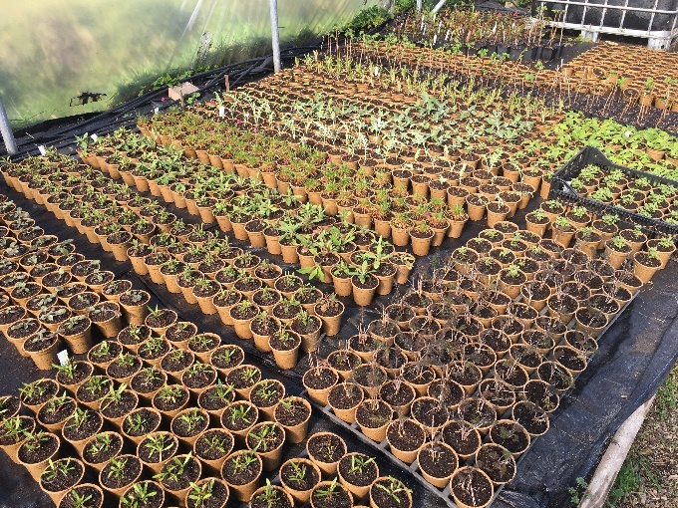

Figure 3. Plant production at Kinsale Campus in 2021. Perennial, pollinator-friendly plants are grown by students using peat-free growing media and plastic-free pots.

The plant sale at Kinsale Campus also acts as an excellent opportunity for students to engage with members of the surrounding community and share knowledge and advice on a range of topics, including the environmentally sustainable production and use of garden plants. It also allows the public to access the campus grounds and see the biodiverse planting schemes that students have implemented over the previous years. Any unsold plants are used to enhance the wildlife value of the landscaped areas within the campus grounds.

Figure 4. Members of the public attending the Spring Plant Sale at Cork ETB’s Kinsale Campus in April 2021

In further efforts to support biodiversity at a local and national level, Kinsale Campus has recently installed bird and bat roosting boxes. Most recently, BirdWatch Ireland supplied the campus with three swift boxes (Fig. 5). The Swift, *Apus apus*, is a migratory bird species to Ireland. They arrive in Ireland in early May and leave again in August. These birds, weighing just 40 grams, fly a distance of 5,000 km over five or six days on their migration journey to and from tropical Africa. Swift numbers are in considerable decline and are listed in the Red Conservation Status. The refurbishment of old buildings has reduced suitable sites for nesting and their food has become scarce due to the use of insecticides. The new boxes at Kinsale Campus will provide new nesting sites and will hopefully augment the numbers of annual migrating Swifts. There are already established colonies in the town of Kinsale at St. Multose Church Tower, in the eaves of the Outdoor Education Centre and at the Municipal Hall.

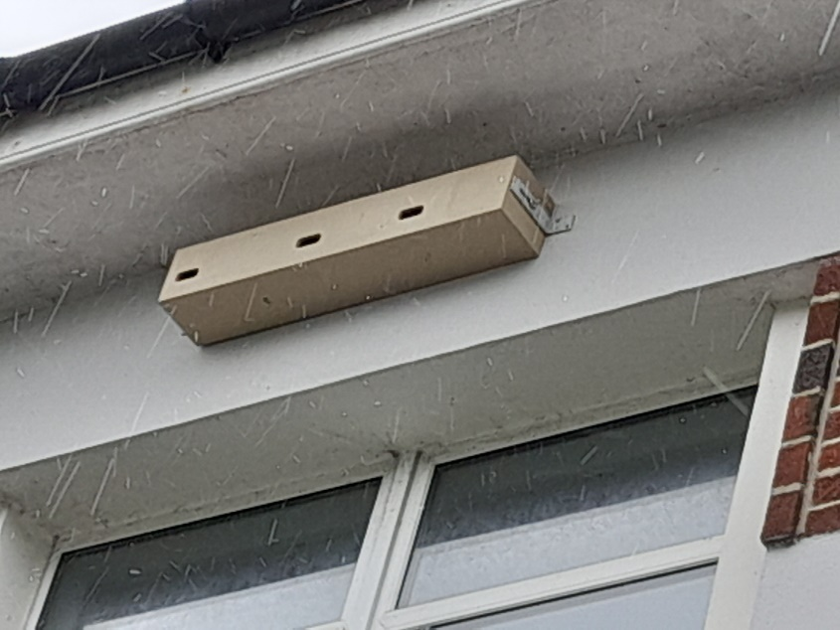

Figure 5. The installation of swift nesting boxes, supplied by Bird Watch Ireland, at Kinsale Campus

Another activity that horticulture students at Kinsale Campus take part in is the collection and propagation of native Irish tree and shrub species. Ireland has one of the lowest tree and forest cover in the European Union. By the 1800’s, Ireland’s once expansive native deciduous woodlands had almost been completely eliminated. The destruction of these woodlands represent a very significant loss to Ireland’s historical diversity of flora and fauna. In the past few years, students have produced Alder (*Alnus glutinosa*), Blackthorn (*Prunus spinosa*), Elder (*Sambucus nigra*), Hawthorn (*Crataegus monogyna*), Hazel (*Corylus avellana*), Oak (*Quercus spp.*) and Rowan (*Sorbus aucuparia*) at the dedicated tree nursery on the campus (see Fig. 6 and Fig. 7). All these species are propagated from wild, locally collected seed and given the appropriate treatment to trigger germination the following Spring. Seedlings are generally grown on for 2 to 3 years in the tree nursery and cared for by the students during this period.

When they have reached a suitable size and age, these young trees are lifted from the nursery and relocated to permanent growing sites. These sites include those of local landowners and gardeners and trees have often been donated to local tree planting initiatives. Trees are also made available to purchase at the annual plant sale that was described earlier.

Figure 6. Students propagating native tree species in Autumn in the seed beds of the tree nursery at the Kinsale Campus. Seeds were previously collected from nearby woodland.

Figure 7. Students lining out one year old seedlings of hazel (*Corylus avellana*) in the tree nursery. These seedlings will need to be grown on for at least another year.

Another use for the trees produced at the campus is in the establishment of new native Irish hedgerows. Hedgerows act as agricultural field boundaries and are a widely recognised key feature of the Irish agricultural landscape. They are also a very important habitat for a very wide variety of plants and animals, given the earlier loss of Ireland’s woodland cover. Despite their critical importance as a semi-natural habitat, hedgerows are under threat in Ireland due to continued agricultural expansion and intensification, road infrastructure development and housing development.

Each year, students on the Level 5 and Level 6 horticulture course take part in the planting of new or the expansion of existing native Irish hedgerows (see Fig. 8). This is achieved through collaboration with local landowners and helps build relationships between the campus and the wider community.

Figure 8. Level 5 horticulture students of Kinsale Campus planting a new hedgerow at a nearby dairy farm with the support of a local landowner (February, 2021).

Other activities focused on biodiversity that learners take part in as part of their studies at Kinsale Campus are habitat surveys of the local environment near the town of Kinsale. This practical activity forms of part of their biodiversity and plant identification studies and follows the current national habitat classification system used in Ireland. Habitats surveyed include a variety of woodland types, hedgerows and built habitats in the form of old stone walls (see Fig. 9). This activity allows learners to explore and compare different habitat types and examine their biodiversity value. Learners are also asked to consider the conservation value of the distinct habitat types and suggest measures that could be implemented in order to protect them.

Figure 9. Students completing a habitat survey in a nearby woodland site.

Related to the woodland habitat survey project is the topic of woodland management. Modern forestry management in Ireland is dominated by the commercial production of timber and relies extensively on the planting of non-native conifer plantations. Native, deciduous tree species represent only a small fraction of trees planted. In the past, traditional woodland management involved the coppicing of deciduous tree species such as willow (*Salix* spp.), hazel, birch (*Betula* spp.), ash (*Fraxinus excelsior*), alder and oak. Learners at Kinsale Campus are given the opportunity to practice this traditional woodland skill as part of their horticultural studies (see Fig. 10). When done correctly, this form of woodland management can enhance the biodiversity value of a woodland and relies on native, deciduous species rather than introduced conifer species that are of limited biodiversity value.

Figure 10. Learners practicing the traditional woodland management skill of coppicing in a nearby woodland site.

**Travel at Kinsale Campus:**

Cork ETB’s Kinsale Campus is located in the small town of Kinsale to the south of Cork City in a picturesque coastal location. Kinsale is a town of Irish historical significance and along with its seaside location, is a very popular tourist destination. It is a 15 to 30 minute car journey from its nearest towns and Cork City (Fig. 11). The town has a public bus service linking it to Cork City and a Local Link bus service to the towns of Bandon and Clonakilty that operates twice per day (morning and evening).

Figure 11. Location of Kinsale town in relation to nearest towns and Cork city.

Kinsale Campus has both a staff carpark (Fig. 12) and a student carpark. Parking space in both carparks is limited and in high demand. Staff at the Kinsale Campus number around 30 teaching and support staff and is made up of both part- and fulltime employees. An EV charging station was installed recently in the staff carpark and is currently used by 3 staff members who use electric vehicles to commute to and from the campus. Very few staff members live in the town of Kinsale and the majority commute via private cars from widely dispersed locations. The campus has 2 mini-buses that carry 16 passengers each and are used for fieldtrips and other student activities.

Figure 12. Limited parking space in the staff carpark at Kinsale Campus.

In recent years, temporary student accommodation in the town of Kinsale has become very limited. In past years, a large number of holiday homes were available to rent by students during the academic term and walking and cycling was a viable transport option for a significant number of learners. Most of these holiday homes are no longer available as owners now rent them through Airbnb and focus on short-term stays. Indeed, Ireland is currently experiencing a national housing crises and rental properties in general are no longer available.

Students at Kinsale Campus are now forced to find accommodation over a much wider area and commute much longer distances to complete their studies. In the early weeks of a new academic year, students tend to organise carpools in order to share transport costs and reduce the reliance on private cars. A formally organised carpooling initiative has yet to be established by Kinsale Campus.