 Sive **Brakel, Germany 2022**

**________________________________________**

**Šiauliai Technology Training Center, Lithuania**



**Biodiversity & Travel**

**Biodiversity at Šiauliai Technology Training Center:**

Our school does not have professions related to agriculture, so we contribute to biodiversity as a community by protecting our environment and participating in various national initiatives.

**Just Do It** project’s (Fig.1) goal was to create environmentally-friendly and rubbish free society when our students cleaned the neighboring green school areas from rubbish, paper and plastic packaging.

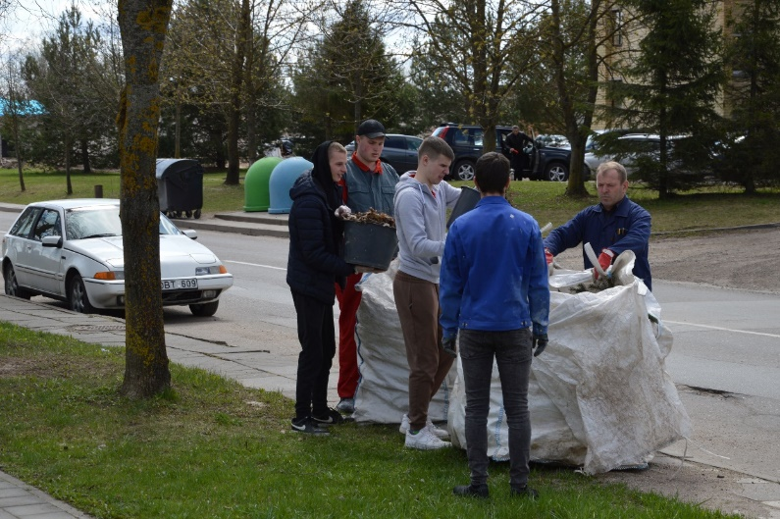

Figure 1. Just Do It project. Cleaning the neighboring green areas

Also, they planted trees in the school area (Fig.2). Doing a street clean-up is one great way to get involved and volunteer. Keeping shared spaces clean allows to get to know neighborhood and build healthier, resilient communities.

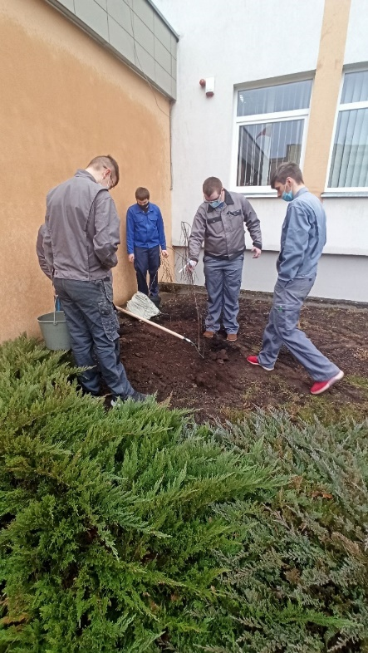

Figure 2. Planting trees in the school arie

For several years in a row teacher of biology organizes a project during which students get to know birds and the peculiarities of their nesting. Pupils make nesting boxes for birds. Some hang out on the trees that are in the school territory, others hang out in a nearby city park.

**Travel at Šiauliai Technology Training Center:**

The Šiauliai Technology Training Centre is the largest educational institution in northern Lithuania. Students come here to study from all over the county (Fig. 3). It has 8 departments which are located all over the city of Šiauliai.

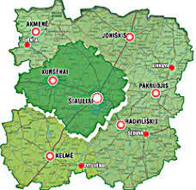  
Figure 3. Counties of Lithuania

The school has several dormitories where most of the students live. They arrive at school on Sunday and leave on Friday. We conducted a survey on the choice of vehicles among students of the Mechanics department. The age of our students varies from 17 to 21 and more. Most of the student arrive to school by public transport. Our students are encouraged to take public transport. Travel costs are reimbursed to students who live in dormitories or commute at least 40 km to school every day. Unfortunately, the survey showed, that most students wouldn‘t forgo personal transport, even if public transport was free. When asked “If you could choose to get any vehicle, would you care about its environmental impact and eco-friendliness?” the majority of students answered that they don‘t pay much attention to a vehicle‘s environmental impact. When asked What is most important when choosing a car? The majority of students cited the model, price, appearance and economy as most important. Only 21 students said it was important to them that the car was environmentally friendly.

The survey showed that there is still a need for education on ecology and sustainability in our society, so taking part in this project is a great opportunity to learn from the practices of other countries.

This year, students are encouraged to take part in the “Steps Challenge” initiated by the President of the Republic of Lithuania (Fig.4).

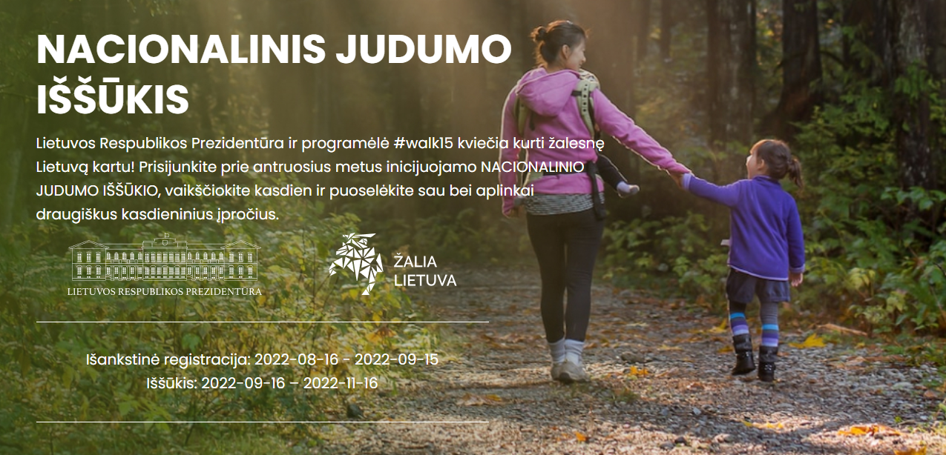

Figure 4. Invitation to take “Steps Challenge”

By swapping cars for steps, we not only take care of our physical and mental health, but also make a significant contribution to cleaner air, greener cities, as well as a better quality of life. It is estimated that a personal vehicle emits an average of 180 grams of CO2 per kilometre. 5 trees are needed to offset these emissions. That‘s why the “Steps Challenge” suggests that a better alternative is to walk that one kilometre, or 1400 steps, and plant 5 virtual trees in doing so. To date, students and teachers at our school have walked a total of 1821507 steps and grown 6598 trees (Fig.5).

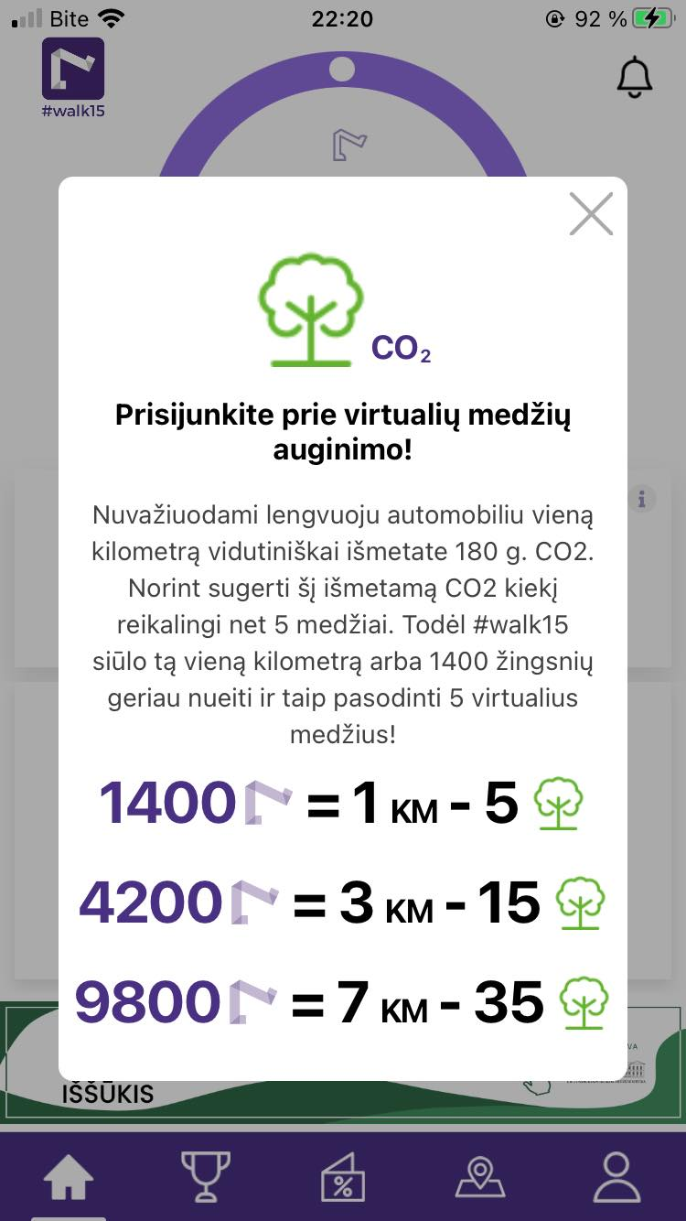

Figure 55. An app that counts steps taken